**OSAYUWA PEACE OSARUMWENSE**

**ENG1507738**

**CPE 522 ASSIGNMENT**

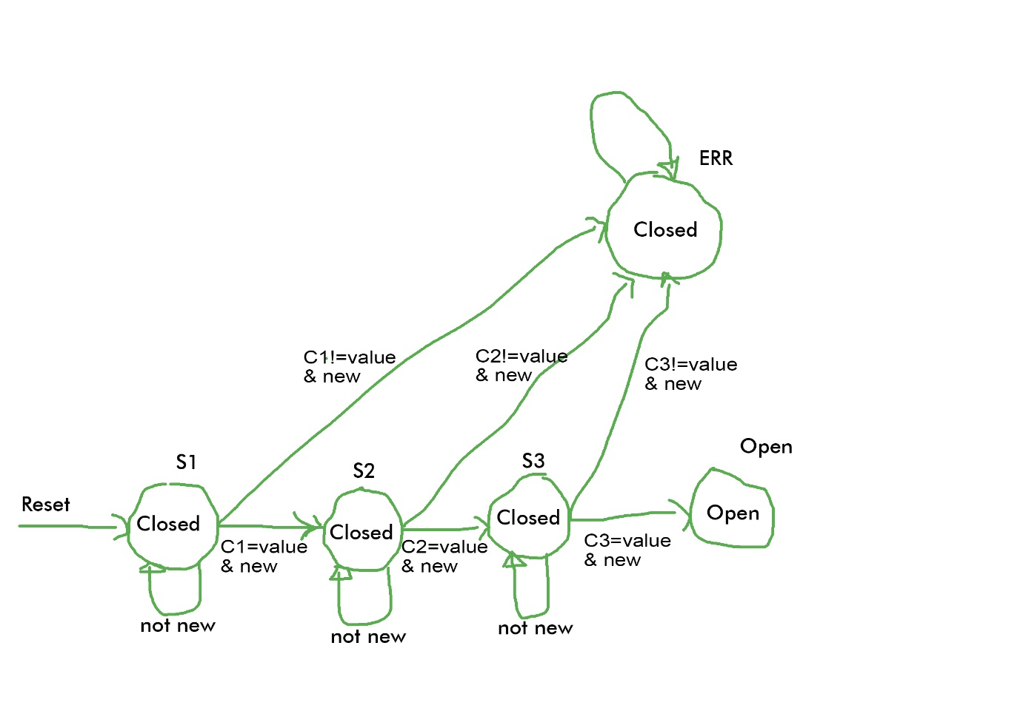

State Diagram of a door combination lock.

State Transition Table

|  |  |  |  |  |  |  |
| --- | --- | --- | --- | --- | --- | --- |
| Reset | New | Equal | Current  State | Next  State | Next  Mux | Open / Closed |
| 1 | X | X | X | S1 | C1 | closed |
| 0 | 0 | X | S1 | S1 | C1 | closed |
| 0 | 1 | 0 | S1 | ERR | X | closed |
| 0 | 1 | 1 | S1 | S2 | C2 | closed |
| 0 | 0 | X | S2 | S2 | C2 | closed |
| 0 | 1 | 0 | S2 | ERR | X | closed |
| 0 | 1 | 1 | S2 | S3 | C3 | closed |
| 0 | 0 | X | S3 | S3 | C3 | closed |
| 0 | 1 | 0 | S3 | ERR | X | closed |
| 0 | 1 | 1 | S3 | OPEN | X | closed |
| 0 | X | X | OPEN | OPEN | X | OPEN |
| 0 | X | X | ERR | ERR | X | closed |

GIVEN STATES AND THE ENCODED VALUE

S1 = 000

S2 = 001

S3 = 010

OPEN = 011

ERR = 100

NEXT MUX AND ENCODED VALUE

C1 = 00

C2 = 01

C3 = 10

STATE ENCODED TABLE

|  |  |  |  |  |  |  |
| --- | --- | --- | --- | --- | --- | --- |
| RESET  (R) | NEW  (N) | EQUAL  (E) | PRESENT STATE  (P0, P1, P2) | NEXTSTATE  (N0, N1, N2) | NEXT  MUX  C0, C1 | OPEN |
| 1 | X | X | XXX | 000 | 00 | 0 |
| 0 | 0 | X | 000 | 000 | 00 | 0 |
| 0 | 1 | 0 | 000 | 100 | XX | 0 |
| 0 | 1 | 1 | 000 | 001 | 01 | 0 |
| 0 | 0 | X | 001 | 001 | 01 | 0 |
| 0 | 1 | 0 | 001 | 100 | XX | 0 |
| 0 | 1 | 1 | 001 | 010 | 10 | 0 |
| 0 | 0 | X | 010 | 010 | 10 | 0 |
| 0 | 1 | 0 | 010 | 100 | XX | 0 |
| 0 | 1 | 1 | 010 | 011 | XX | 0 |
| 0 | X | X | 011 | 011 | XX | 1 |
| 0 | X | X | 100 | 100 | XX | 0 |

The inputs variables are therefore: R, N, E, P0, P1, P2

The outputs variables are therefore: N0, N1, N2

For first output N0:

Min-terms: (4, 12, 16, 17, 18, 20, 28)

1. Prime implicant chart

|  |  |  |  |  |  |  |  |  |
| --- | --- | --- | --- | --- | --- | --- | --- | --- |
| PIs\Minterms | 4 | 12 | 16 | 17 | 18 | 20 | 28 | R,N,E,P0,P1,P2 |
| 16,17 |  |  | X | X |  |  |  | 01000- |
| 16,18 |  |  | X |  | X |  |  | 0100-0 |
| 16,20 |  |  | X |  |  | X |  | 010-00 |
| 4,12,20,28 | X | X |  |  |  | X | X | 0--100 |

Extracted essential prime implicants: 0--100,01000-,0100-0

All extracted essential prime implicants: 0--100,01000-,0100-0  
Minimal Quin McCluskey Expression = R'P0P1'P2' + R'NE'P0'P1' + R'NE'P0'P2’

For second output N1:

Min-terms: (2, 3, 10, 11, 19, 25, 26, 27)

 Prime implicant chart

|  |  |  |  |  |  |  |  |  |  |
| --- | --- | --- | --- | --- | --- | --- | --- | --- | --- |
| PIs\Minterms | 2 | 3 | 10 | 11 | 19 | 25 | 26 | 27 | R,N,E,P0,P1,P2 |
| 25,27 |  |  |  |  |  | X |  | X | 0110-1 |
| 2,3,10,11 | X | X | X | X |  |  |  |  | 00-01- |
| 3,11,19,27 |  | X |  | X | X |  |  | X | 0--011 |
| 10,11,26,27 |  |  | X | X |  |  | X | X | 0-101- |

Extracted essential prime implicants: 00-01-,0--011,0110-1,0-101-

All extracted essential prime implicants: 00-01-,0--011,0110-1,0-101-  
Minimal Quin McCluskey Expression = R'N'P0'P1 + R'P0'P1P2 + R'NEP0'P2 + R'EP0'P1

For third output N2:

Min-terms: (1, 3, 9, 11, 19, 24, 26, 27)

Prime implicant chart

|  |  |  |  |  |  |  |  |  |  |
| --- | --- | --- | --- | --- | --- | --- | --- | --- | --- |
| PIs\Minterms | 1 | 3 | 9 | 11 | 19 | 24 | 26 | 27 | R,N,E,P0,P1,P2 |
| 24,26 |  |  |  |  |  | X | X |  | 0110-0 |
| 26,27 |  |  |  |  |  |  | X | X | 01101- |
| 1,3,9,11 | X | X | X | X |  |  |  |  | 00-0-1 |
| 3,11,19,27 |  | X |  | X | X |  |  | X | 0--011 |

Extracted essential prime implicants: 00-0-1,0--011,0110-0

All extracted essential prime implicants: 00-0-1,0--011,0110-0  
Minimal Quin McCluskey Expression = R'N'P0'P2 + R'P0'P1P2 + R'NEP0'P2’

For fourth output OPEN:

Min-terms: (3,11,19,27)

Prime implicant chart

|  |  |  |  |  |  |
| --- | --- | --- | --- | --- | --- |
| PIs\Minterms | 3 | 11 | 19 | 27 | R,N,E,P0,P1,P2 |
| 3,11,19,27 | X | X | X | X | 0--011 |

Extracted essential prime implicants: 0--011

All extracted essential prime implicants: 0--011  
Minimal Quin McCluskey Expression = R'P0'P1P2